Hand Gesture Recognition and Voice Conversion for Deaf and Dumb

In this paper author is building machine learning model which can predict hand gesture from webcam and then convert recognize gesture into voice so normal peoples can understand what Deaf and Dumb peoples are saying.

In propose paper author has used SVM algorithm but in python SVM is not accurate in identifying hand gesture so we are using deep learning Convolution Neural Network to train hand gesture images and then this trained model can be used to predict those trained hand gesture from webcam.

To train CNN we have used below dataset

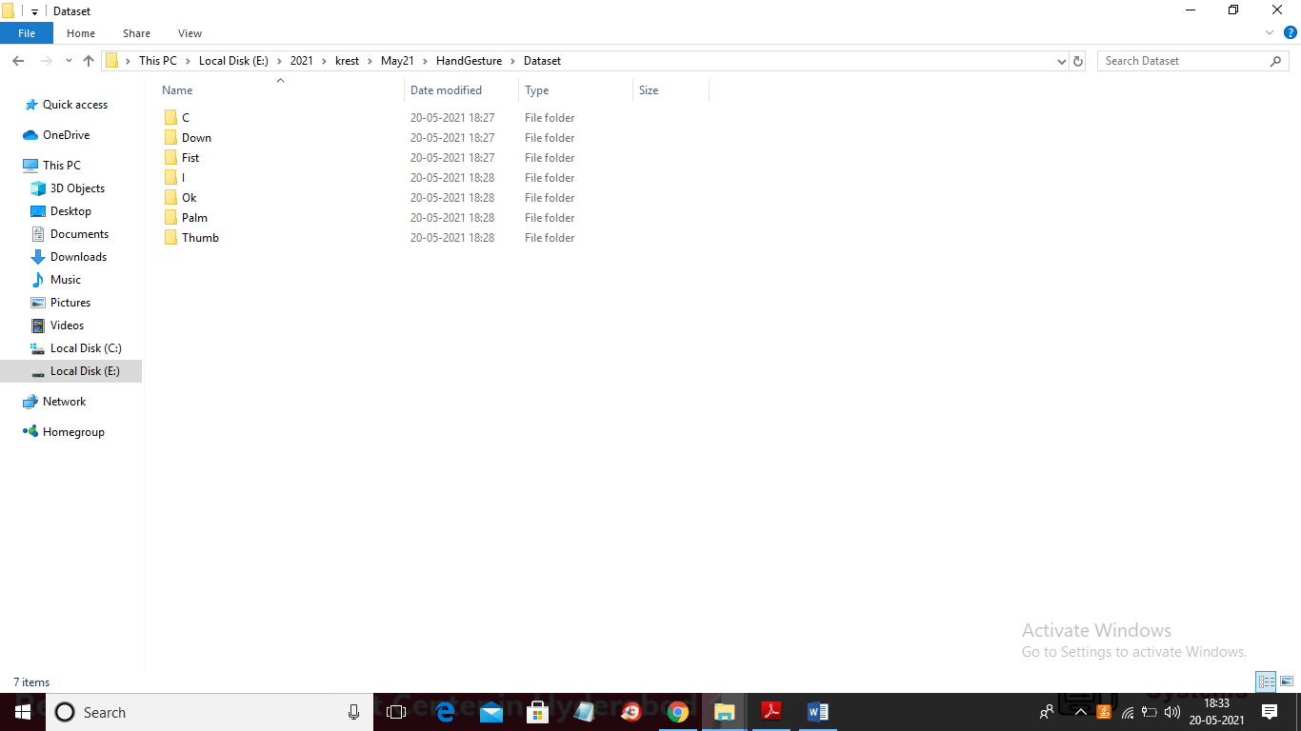

In above dataset we have seven different types of images such as thumbs up, down, C, I, OK etc. This is computer program so it can predict 8 times correctly out of 10. Just we need to show gesture in webcam properly.

To run project double click on ‘run.bat’ file to get below screen

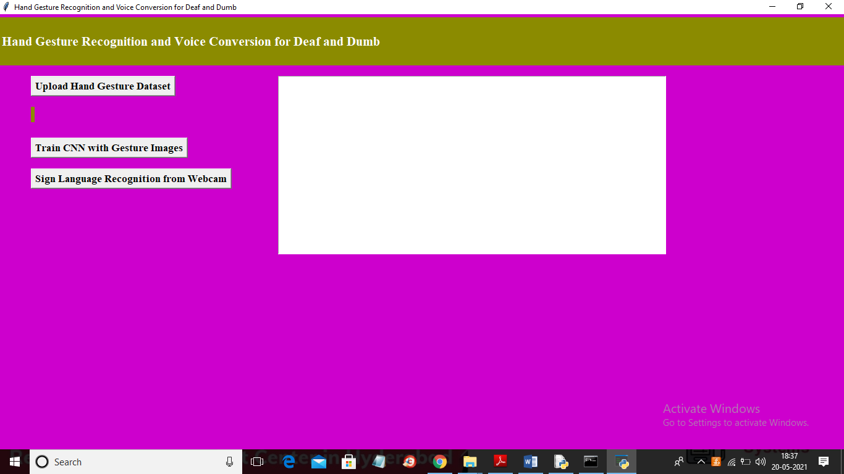

In above screen click on ‘Upload Hand Gesture Dataset’ button to upload dataset

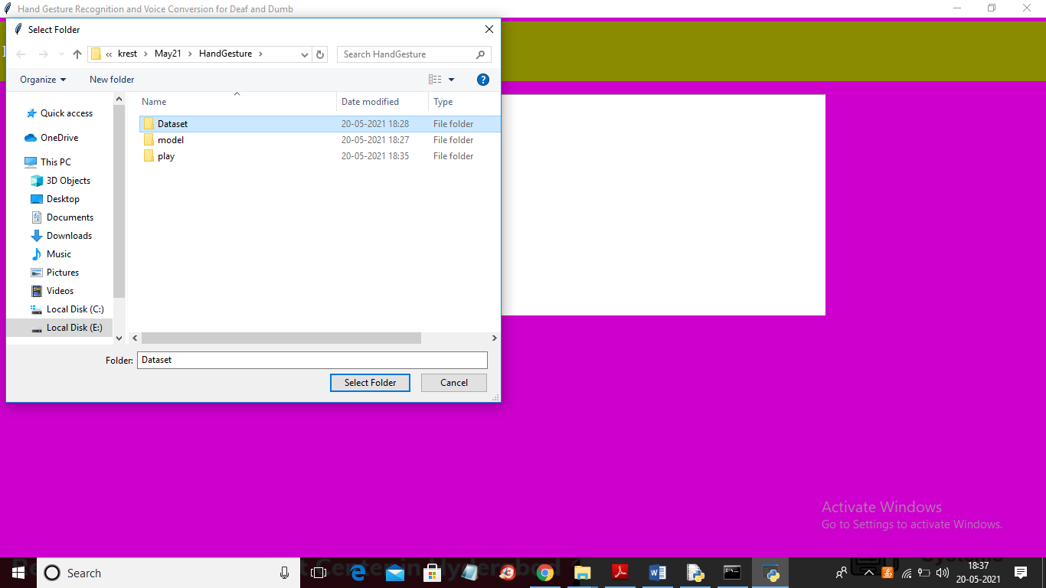

In above screen selecting and uploading ‘Dataset’ folder and then click on ‘Select Folder’ button to load dataset and to get below screen

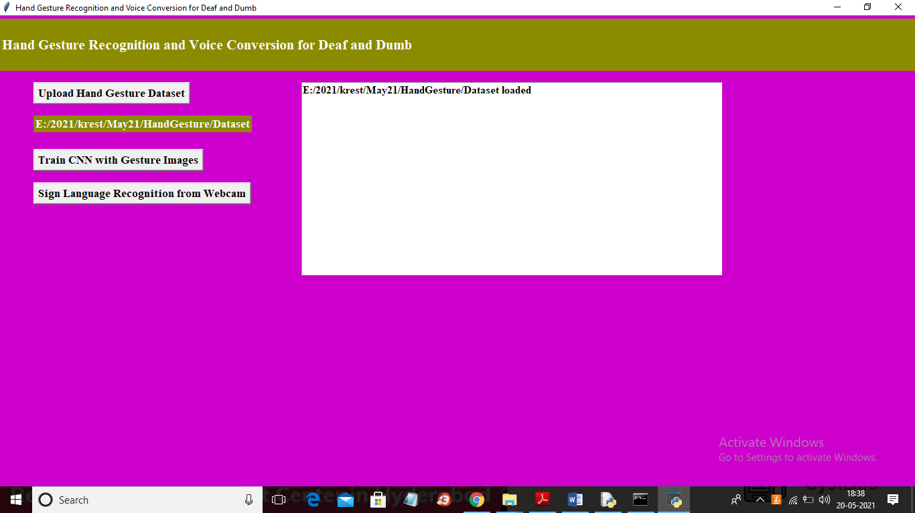

In above screen dataset loaded and now click on ‘Train CNN Gesture Images’ button to train Model

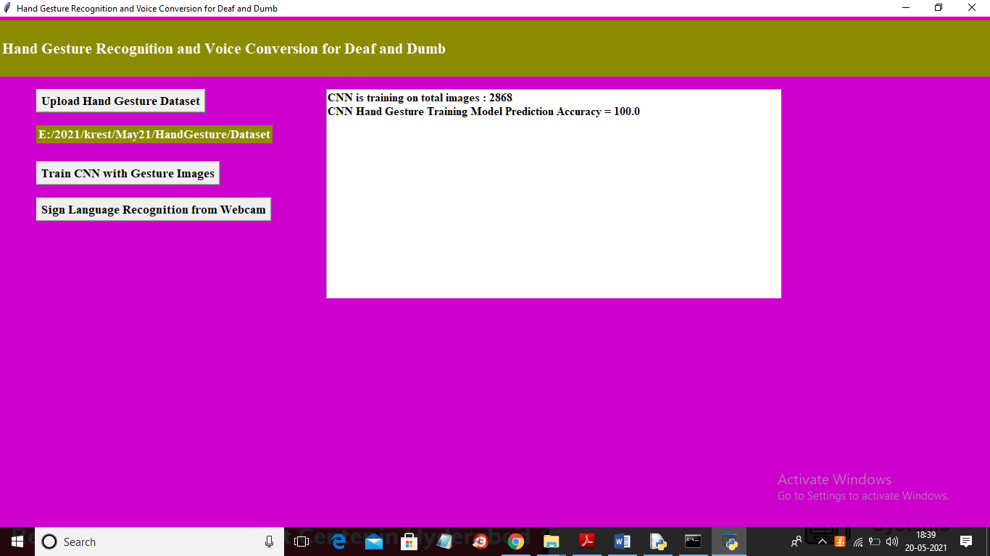

In above screen CNN model generated and now click on ‘Sign Language Recognition from Webcam’ button to get below screen

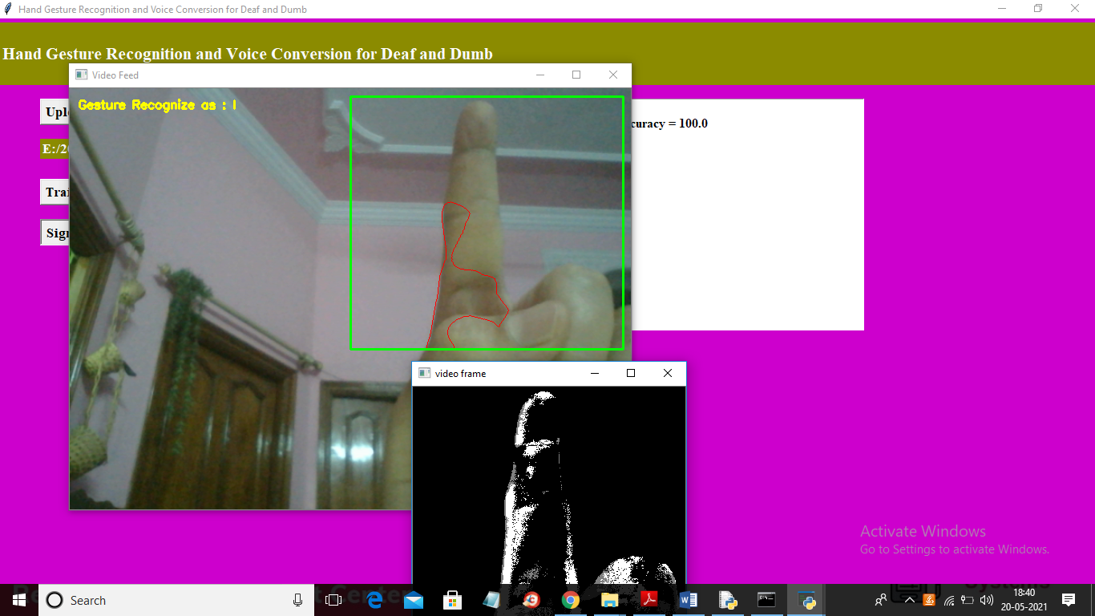

In above screen just show ur hand gesture in green colour rectangle box then application will recognize and then play it as voice

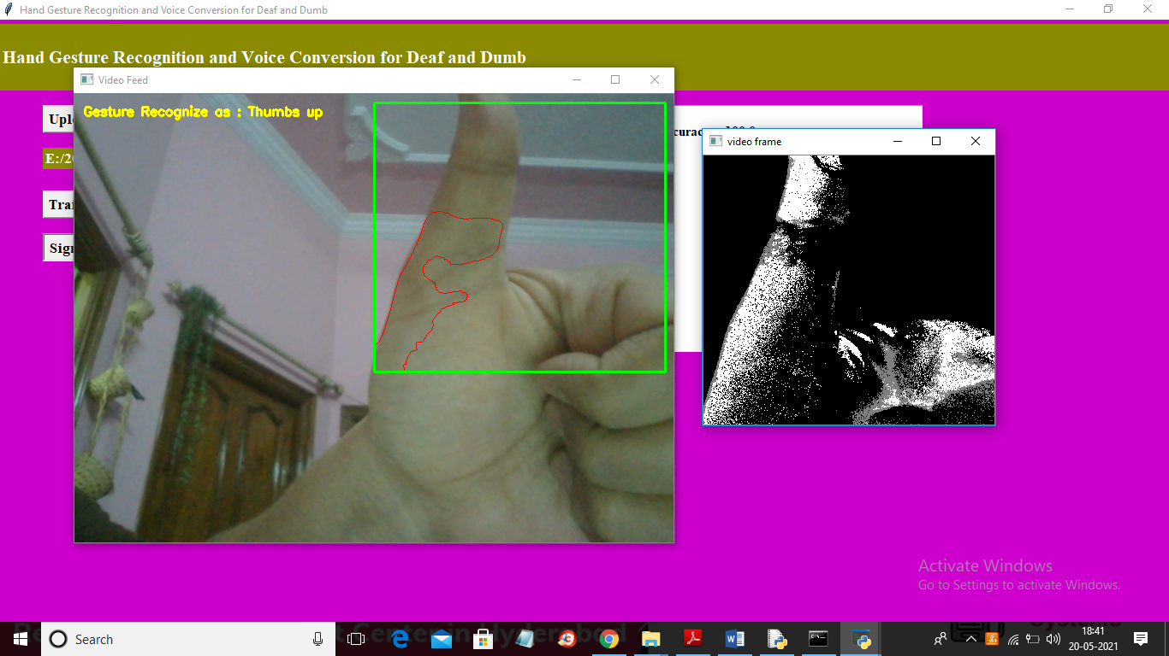

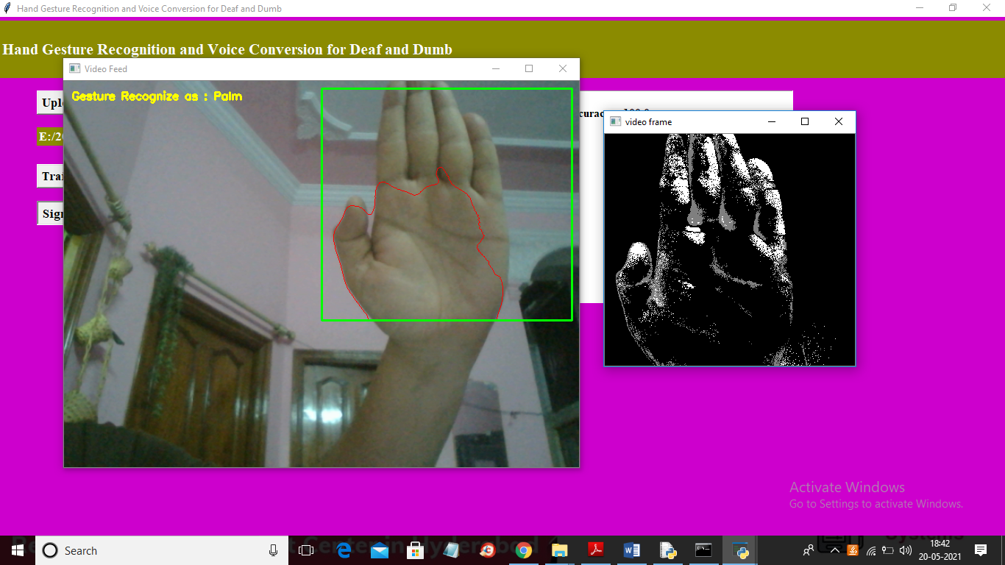

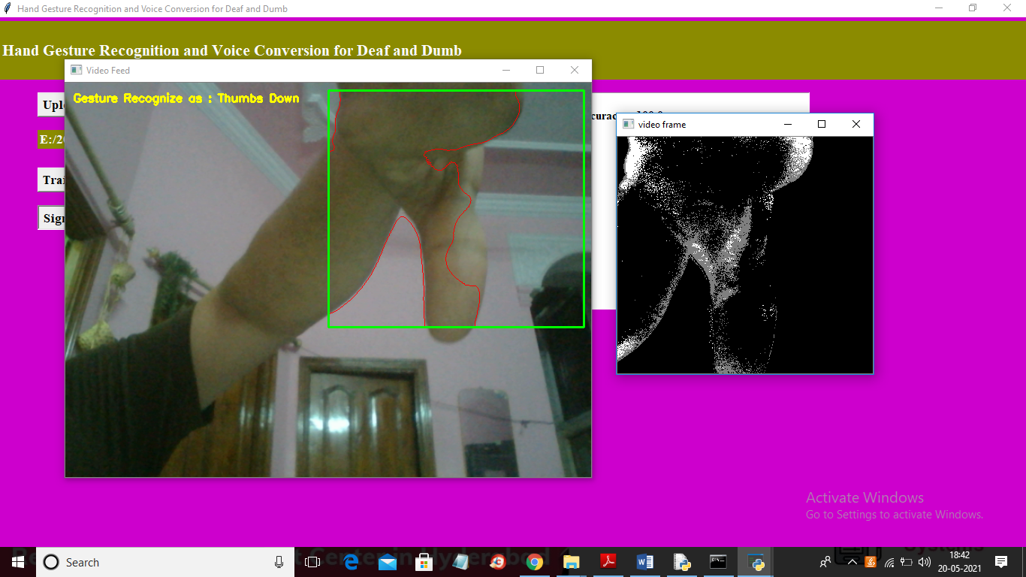

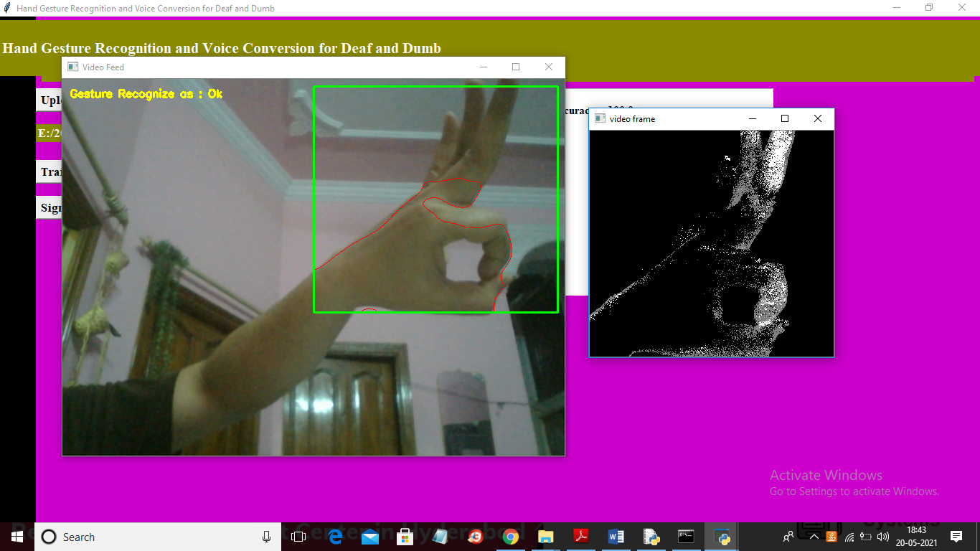

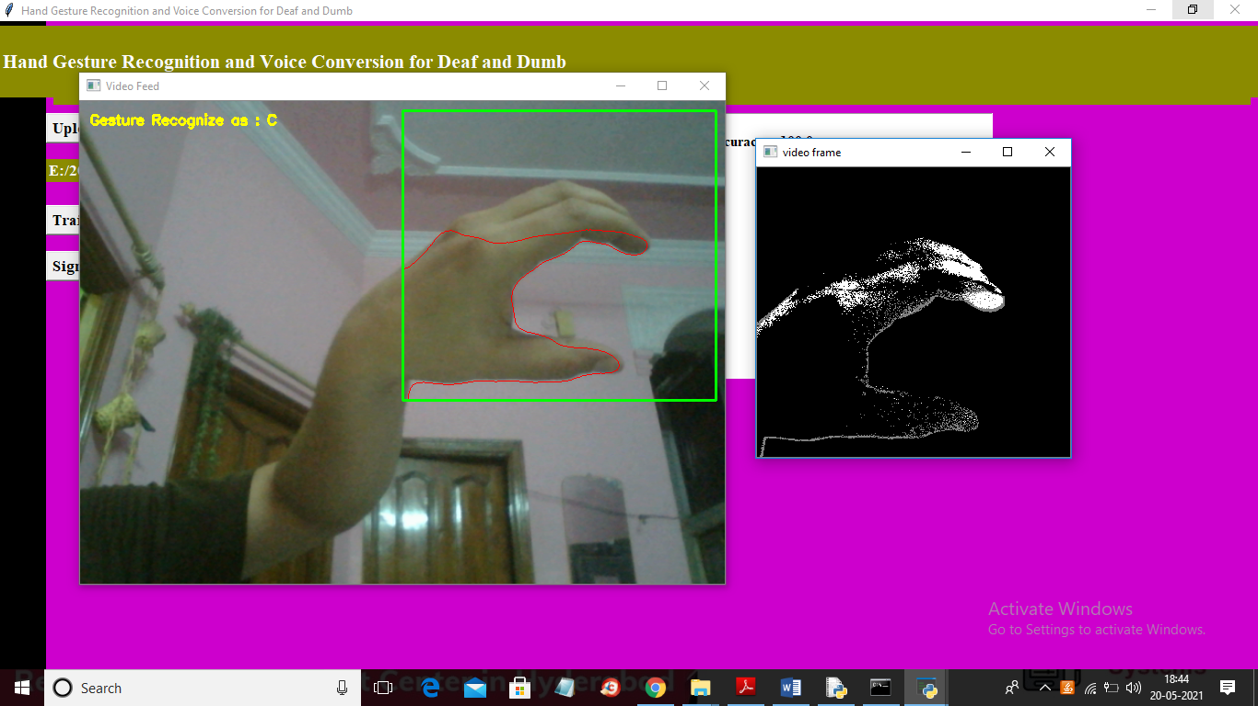

Here just you need to show gesture properly as shown in above screen and while adjusting your hands u may get wrong prediction but when u correct u correct ur gesture then prediction will go accurate.

When we run project for each prediction following modules get executed

1. Extract image from webcam
2. Convert image to binary or grey format and back ground removal
3. Extract features from image
4. Recognition and play audio